Kedelaron

Notes to Future programmers

* Do a bit of research and make a plan before writing any code, as this will save you many hours of frustration
* add more precise hit detection for the enemies and main character, possibly look into using box2d
* Learn the libgdx structure before trying do things
* there's no such thing as a scratch to small. (prototype everything)
* add animation to player and enemies.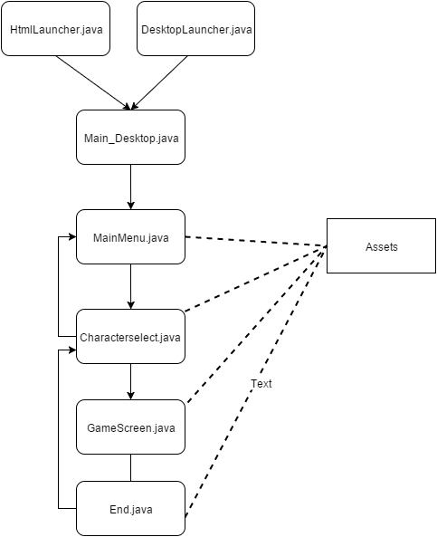

Flow chart of desktop file system

mobile file system flow chart

